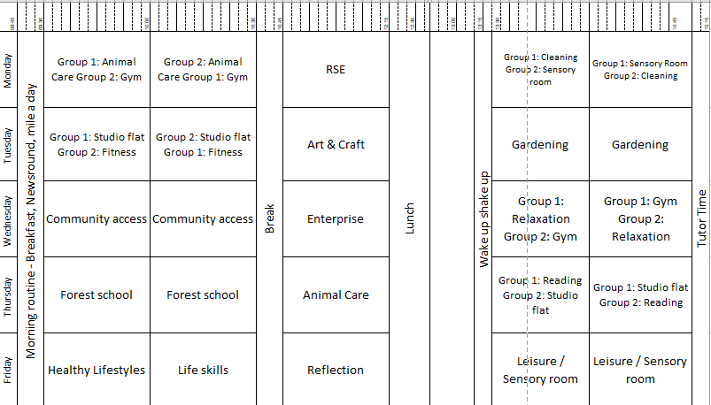
Key Stage 5 Extended timetable
Lesson overview:
Animal care – Students will be developing their knowledge of our guinea pigs, including their names and whether they are male or female. They will also focus on the equipment needed to look after a guinea pig.
Healthy Lifestyles – Students will take part in using the gym and accessing fitness sessions including Joe Wickes PE on YouTube.
Life skills – Students will be developing their skills in preparing different drinks and snacks, cleaning, washing clothes and washing dishes.
Community Access – This term students will visit Cannon Hill park and the café on Wednesday mornings. We will also be visiting furniture shops to gain ideas for furnishing the studio flat.
Enterprise – The focus of enterprise this term will be to make items that can be sold for Halloween, Diwali and Christmas. The students have already come up with some great ideas, so keep an eye out for adverts and order forms in their planners.
RSE – Rights and responsibilities – Students will explore rights and responsibilities at school, home and in the community.
Reflection – Students will be developing their communication skills during these sessions, they will reflect on their week by looking at photos and then have the opportunity to discuss this with their peers.
Gardening – Students are developing their knowledge of the safe use of tools and equipment used for gardening and how to use these. They have been learning how to weed the raised beds and picking vegetables that grew over the summer.

