Key Stage 5 Main timetable
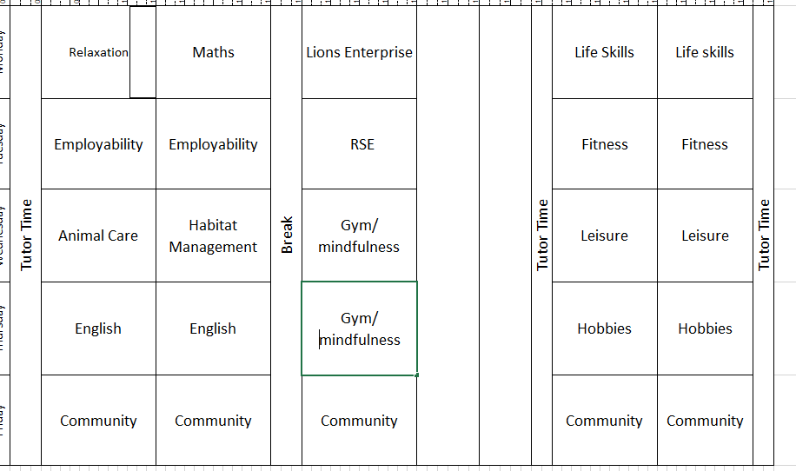
Curriculum Overview
Community access will take place every Friday to allow students to practice the skills they are developing in school, within the community. As part of these sessions, students will do a weekly food shop for their break time snacks and drinks, as well as planning and leading their own trips to different places in Birmingham.
English will give students the chance to read, watch, perform and adapt Shakespeare’s plays, with a specific focus on Shakespeare’s Othello.
Maths will be exploring time and date for Autumn term 1 and money management for Autumn term 2. Students will also be given the opportunity to implement these skills in the community by organising and planning their own trips and managing their money in the community.
Life Skills will focus on the development of household skills. In Autumn term 1 students will be given the opportunity to furnish, decorate and maintain the studio flat, as well as learning how to wash, iron and care for their clothes. Autumn 2 will focus on cleaning, with students learning the importance of cleanliness, how to clean and personal hygiene.
Employability ‘induction to college’ module for Autumn term 1. Students will familiarise themselves with Russell Road, learning about staff, roles, responsibilities and safety to help them settle into college. For Autumn term 2, KS5Main will undertake an Enterprise project. Students will be inspired by the work of Jackson Pollock and will create, sell and advertise their own artwork to sell for profit.
Fitness sessions will include use of the onsite gym, and outdoor space. Students will be introduced to a range of different fitness sports and games including; badminton, cricket, ball games, walks and yoga. In addition to this, students will also partake in relaxation sessions where they will learn about different forms of relaxation such as, meditation, hand massages and mindfulness colouring.
Animal Care will partake in practical sessions learning how to feed, clean and safely care for our onsite guinea pigs. Students will also learn how to manage habitat, helping to build and maintain a habitat for garden birds.
Hobbies will introduce students to a range of different activities with the aim of discovering new and enjoyable recreational activities. During these sessions, students will be given the opportunity to explore; music, drawing, painting, origami, sewing, poetry, board games and film.

