
Class: KS3 Campbell
Spring Term Overview
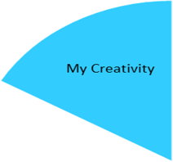

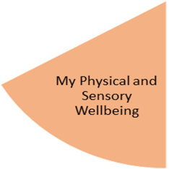
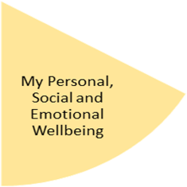
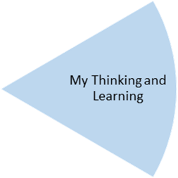
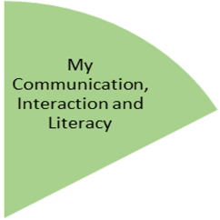
This terms focus is on Wonderful Weather; we will be reading the fantastic book A Wonderful World of Weather by Kay Barnham. Each week we will explore a different type of weather and what we should be wearing. We will be focusing on using adjectives to describe different types of weather and creating weather poetry.

In Creativity we will be exploring different types of weather through Art. We will be using a variety of mediums and textures such as painting, play dough making and collage making.
Weekly Open Theatre and music sessions will continue.

We hope to be able to go out on lots more outings. On Fridays we will be venturing out in the minibus on a variety of travels such as the Lickey Hills and local supermarkets.
In life skills we will be thinking about who helps us and how we can ask for help.
Forest school will continue on Wednesdays.

In PE the class there will be a focus on Gym where they will be rolling, moving and balancing. Whilst Dance they will be focused on rhythm, tempo and emotions.
We are also swimming every Thursday during Spring 1.

In Personal care we will be focusing on Hygiene and how we keep ourselves clean and healthy.
In Independence we will continue to work on cleaning with a focus on clothing’s and how we look after our clothes.

This term we will be focusing on Measurement for maths. We will be covering length & height as well as weight & volume. We will be doing this throughout the curriculum; not just in Maths. All of the maths lessons will link to the theme such as measuring rain water and ordering weather themed objects by size.

My Physical and Sensory Wellbeing lessons, pupils will have the opportunity to discover and learn to self-regulate their sensory needs. Pupils will participate in a range of lessons such as PE, cooking and movement breaks to develop an awareness of their body, senses and further developing fine and gross motor skills under the thematic approach.

My Community and Wider World
lessons, pupils will have the opportunity to explore the world around them through forest school and trips to places outside of school to build up engagement under the thematic approach.

My Creativity lessons are based around child-led activities giving pupils the ability to explore their creativity and develop engagement through art, music, and open theatre under the thematic approach.

