
Class: Osborne Class -Spring1
Spring Term Overview
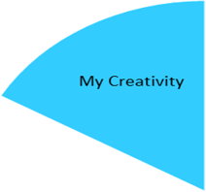

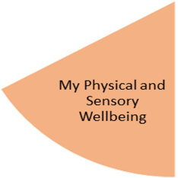
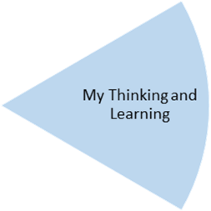
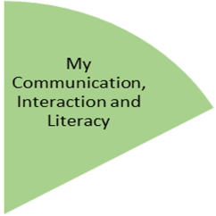
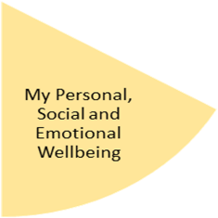
Students will listen to stories and songs, to retain the language including object names in different environments. We will use a text book about all seasons to develop their understanding of past and future tense whilst learning about the weather and our environment with related key vocabulary. In writing, students will have opportunities to develop their mark making and handwriting, as well as simple short sentence formation.

In P.E. the topic is Gymnastics which includes learning skills such as movement, balance & rolling. They will also explore Dance, considering rhythm, emotions & tempo.

My Independence
My Health and Wellbeing
Preparing for My Future
In Art our students will be exploring different materials and their textures to create collages by sticking. Music and drama sessions will continue to be provided through our Open Theatre sessions and visiting music teacher.
Pupils will go to Forest School and take opportunities to visit local parks and other outdoor venues. The learning of these outdoor pursuits will be weather related and how it affects us as they develop understanding of the seasons.

My Physical and Sensory Wellbeing lessons, pupils will have the opportunity to discover and learn to self-regulate their sensory needs. Pupils will participate in a range of lessons such as PE, cooking and movement breaks to develop an awareness of their body, senses and further developing fine and gross motor skills under the thematic approach.

My Community and Wider World
lessons, pupils will have the opportunity to explore the world around them through forest school and trips to places outside of school to build up engagement under the thematic approach.

My Creativity lessons are based around child-led activities giving pupils the ability to explore their creativity and develop engagement through art, music, and open theatre under the thematic approach.

In science we will have weather and season based lessons exploring different materials and shapes by observing and exploring their environment to understand vocabulary like wet/dry waterproof not waterproof. This links in with our maths focus which is number and measurement, understanding different amounts and matching numbers to the correct quantity. They will also explore materials and their properties like heavy or light full or empty. They will continue their understanding measurement of time relating to days of the week and months of the year.

Pupils will continue to understand how to keep clean and develop understanding of making healthy choices. They will explore what and how to wear the appropriate clothes according to the weather. They will also continue to learn about road safety and keeping safe.

