
Class: KS3 Darby
Spring Term 1 Overview
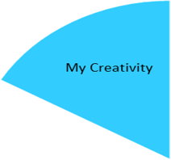

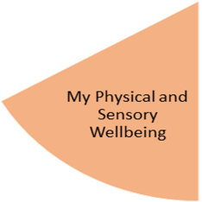
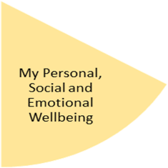
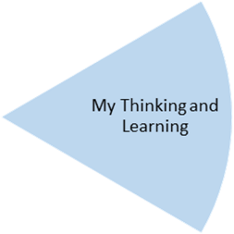
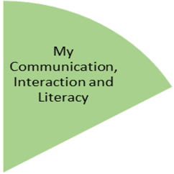
By the end of the topic— Pupil’s will have further developed their experiences of art based activities through collage creating based around ‘weather’ using a variety of objects/pictures
Pupil’s will have attended music lessons and Open Theatre, delivered by an outside agency.

By the end of the topic— Identify suitable clothing to wear in different weather conditions and showing awareness of potential changes.
Pupil’s will have experienced learning outside the classroom through forest school sessions, visiting the shops, visiting local community

My Independence
My Health and Wellbeing
Preparing for My Future
By the end of the topic the children will have covered –
Gymnastics – movement, balance & rolling
Dance – rhythm, emotions & tempo

By the end of the topic—Show understanding of keeping themselves healthy through different types of exercise and Food. Recognising different body parts and how these may change/develop as they get older.
Food technology – Seasonal foods and ‘Winter Warmers’

By the end of the topic— Have basic understanding of different types of measurement and how lots of objects can be measured differently.
Identify a variety of textures (linked to seasons) and how this affects the environment around us.

By the end of the topic— Pupils will show an understanding of a variety of different weather conditions and their seasons. Using descriptive words/vocabulary/sentences to analyse each season and be able to acknowledge some environmental changes occurring in each of the four seasons.

My Physical and Sensory Wellbeing lessons, pupils will have the opportunity to discover and learn to self-regulate their sensory needs. Pupils will participate in a range of lessons such as PE, cooking and movement breaks to develop an awareness of their body, senses and further developing fine and gross motor skills under the thematic approach.

My Community and Wider World
lessons, pupils will have the opportunity to explore the world around them through forest school and trips to places outside of school to build up engagement under the thematic approach.

My Creativity lessons are based around child-led activities giving pupils the ability to explore their creativity and develop engagement through art, music, and open theatre under the thematic approach.

