
Class: Norton Class -Spring1
Spring Term Overview
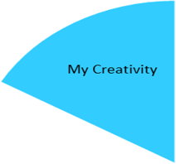
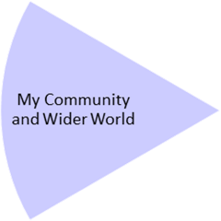
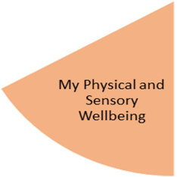
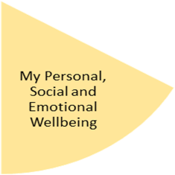
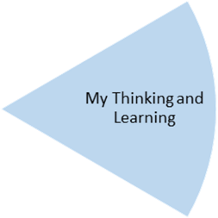
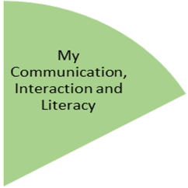
This term, students will continue to consider healthy lifestyles and making healthy choices, including how to keep clean. They will explore growing and aging and how our needs change from young to old. They will also continue to learn about road safety and keeping safe.
Students will listen to stories, poems and songs, exploring the language including descriptive words and phrases. They will develop their retrieval skills, using non-fiction texts/images to find things out and link learning to facts about the weather and climate. In writing, students will have opportunities to develop their mark making and handwriting, as well as sentence formation and structure for a range of purposes.

In maths/number work, students will experience counting in steps, measuring, including weights, lengths and capacity. They will also consider measurements of time relating to days of the week and months of the year. In our science -based experiences, students will explore the weather and seasons, linking the learning with measurements. They will also explore materials and their properties. Computing will link to retrieving information and how to do this safely, as well as using computers to make posters and display information.

In P.E. over the term, students will be covering Gymnastics, including movement, balance & rolling. They will also explore Dance, considering rhythm, emotions & tempo.

My Independence
My Health and Wellbeing
Preparing for My Future
Music and drama sessions will continue to be provided through our Open Theatre sessions and visiting music teacher. In our creative sessions, students will link their learning on materials to exploring textures and creating collages and weaving.
Students will continue with Forest School opportunities, as well as take visits to local parks and facilities. They will develop an awareness of weather-related leisure pursuits and how the weather impacts on human activity. They will link their learning on the seasons to weather around the world.

My Physical and Sensory Wellbeing lessons, pupils will have the opportunity to discover and learn to self-regulate their sensory needs. Pupils will participate in a range of lessons such as PE, cooking and movement breaks to develop an awareness of their body, senses and further developing fine and gross motor skills under the thematic approach.

My Community and Wider World
lessons, pupils will have the opportunity to explore the world around them through forest school and trips to places outside of school to build up engagement under the thematic approach.

My Creativity lessons are based around child-led activities giving pupils the ability to explore their creativity and develop engagement through art, music, and open theatre under the thematic approach.

