
Spring Term Overview
Class: Tolkien Y11
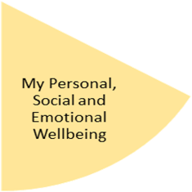
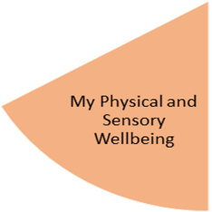
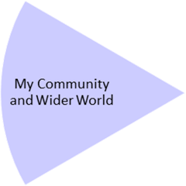
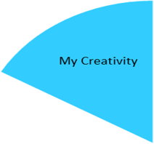
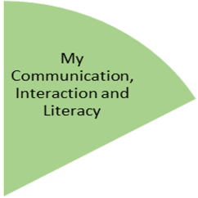
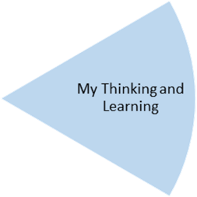
Mathematics (Entry Level Certificate):
Set 1: Money, Ratio, Geometry. Students will: carry out investigations using money, including calculating the correct change; recognise equivalent fractions; add and subtract fractions; identify horizontal, vertical and parallel lines; use grid co-ordinates to denote position.
Set 2/3: Money, Calendar and Time, Statistic. Students will: use decimal notation for money including on a calculator display; solve real life problems; read an analogue and digital clock; know how to use a calendar; interpret and construct lists, pictograms and graphs; estimate length, weight and capacity of given items; measure and draw lines in mm and cm.
Careers :
My Choices for a Future Career. Using resources from Barclays Life Skills, students will assess their personal strengths and skills, research possible career pathways and explore potential post-16 colleges.
Science (Entry Level Certificate):
Electricity and Energy. Students will: learn how electricity is produced, the difference between a conductor and an insulator and the importance of power stations in our everyday life.

My Independence
PHSE: Accidents and Risk, Emergency Situations, Keeping Safe Online. Students will: identifying how to deal with potential everyday dangers eg at home, on the road and online, including how to contact the emergency services.
Food: Working towards the ASDAN Foodwise short course: Students will be studying the ‘Healthy Eating’ module.
They will: identify food groups and nutrients; consider healthy menus and design sustainable food packaging.
Physical Education: Students will: engage in three different types of sports this half term and learn about the different movements involved in each.

Gymnastics – movement, balance & rolling
Dance – rhythm, emotions & tempo
Health Related Exercise (HRE) – circuits, weights & resistance

Art: Working towards the Bronze Arts Award
Y10: Exhibitions and Graffiti. Students will: visit an exhibition at the MAC; create a class exhibition in school; exploring graffiti as a form of expression and creating own examples; visit the Digbeth Graffiti Trail.
Y11: Sculpture: Students will be studying gargoyles in the built environment and then creating their own using papier mache.

Preparing for My Future
My Health and Wellbeing
Forest School: working towards Duke of Edinburgh Award. Activities to include maintenance work at the Forest School site at Woodlands and volunteering at the Canal Trust.
Geography: Sport and Leisure; Big Issues. Students will consider own leisure activities and how to monitor them; design an ideal sports centre; plan journeys to attend sports venues abroad. In a study of natural disasters students will map global hunger, identify local fast food restaurants and consider their advantages and disadvantages.

English (Entry Level Certificate): Detectives; Travel. Over the two topics, students will study texts based on solving a crime and holidays. Skills used will include retrieving key points, using adjectives to sustain interest in writing, making predictions about characters’ actions and motives, using capital letters, full stops, question and exclamation marks in grammatically correct sentences. Students will also make and record a presentation on a related topic.
Open College Network: Students will focus on reading and interpreting instructions, giving oral instructions and writing instructions.

My Physical and Sensory Wellbeing lessons, pupils will have the opportunity to discover and learn to self-regulate their sensory needs. Pupils will participate in a range of lessons such as PE, cooking and movement breaks to develop an awareness of their body, senses and further developing fine and gross motor skills under the thematic approach.

My Community and Wider World
lessons, pupils will have the opportunity to explore the world around them through forest school and trips to places outside of school to build up engagement under the thematic approach.

My Creativity lessons are based around child-led activities giving pupils the ability to explore their creativity and develop engagement through art, music, and open theatre under the thematic approach.

