
Class: KS5M
Spring Term Overview
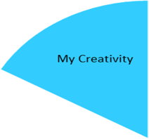
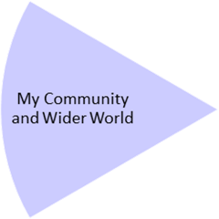
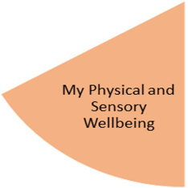
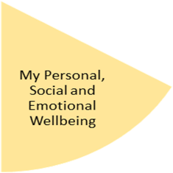
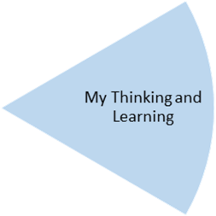
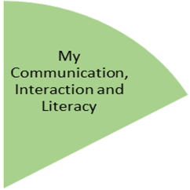
My Independence
My Health and Wellbeing
Preparing for My Future
- Students will be able to create a mask based around their favourite movie villain.
- Students will demonstrate how to get about safely by travelling and exploring different parts of Birmingham.
- Students will recognise harmful content and explain how to stay safe online in a group presentation.
- Students will be able to describe the importance of keeping fit by taking part in an exercise programme.
- Students will buy, prepare and cook ingredients for different foods from around the world.

- Students will be able to measure and weigh ingredients to make potions.
- Students will be able to dress and act appropriately for the workplace by preparing for a workplace visit.
- Students will be able to follow to pet care guides to successfully care for guinea pigs and rabbits
- Students will be able to lead and take part in a debate on a real-life issue.

My Physical and Sensory Wellbeing lessons, pupils will have the opportunity to discover and learn to self-regulate their sensory needs. Pupils will participate in a range of lessons such as PE, cooking and movement breaks to develop an awareness of their body, senses and further developing fine and gross motor skills under the thematic approach.

My Community and Wider World
lessons, pupils will have the opportunity to explore the world around them through forest school and trips to places outside of school to build up engagement under the thematic approach.

My Creativity lessons are based around child-led activities giving pupils the ability to explore their creativity and develop engagement through art, music, and open theatre under the thematic approach.

