
Class: KS3 Campbell
Summer Term Overview
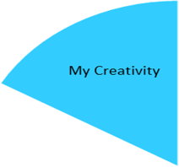
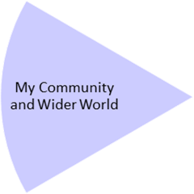
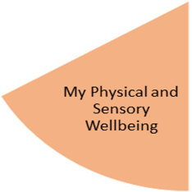
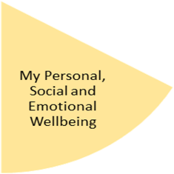
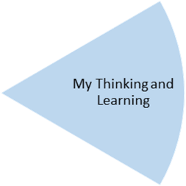
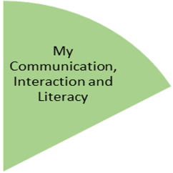
In Creativity we are focusing on Craft and Textiles. We will be making figurines, pom poms, practicing our sewing skills and weaving.
Weekly Open Theatre and music sessions will continue.

Every Friday we will be going to the supermarket to buy our own food for our weekly cooking lessons.
Forest school will continue on Wednesdays.
In PE the call will be focusing on Gymnastics & Dance . This will involve travelling, rolling, balancing, tempo, rhythm, sequencing & expression.
In Personal Care we will be focusing on self care and the importance of keeping good personal hygiene.
In PSHE the theme is belonging; we will focus on ourselves, our family and our communities. Exploring what, where and who we belong with in our lives.
This term we will be focusing on position and Direction in Maths. We will be covering prepositional language, ordering by size, ordering and sequencing events.

This terms focus is on The World Around me. We will be focusing on ourselves, our families, our local area and our different religions/ celebrations. We will be exploring our world through the use of our senses,

My Physical and Sensory Wellbeing lessons, pupils will have the opportunity to discover and learn to self-regulate their sensory needs. Pupils will participate in a range of lessons such as PE, cooking and movement breaks to develop an awareness of their body, senses and further developing fine and gross motor skills under the thematic approach.

My Community and Wider World
lessons, pupils will have the opportunity to explore the world around them through forest school and trips to places outside of school to build up engagement under the thematic approach.

My Creativity lessons are based around child-led activities giving pupils the ability to explore their creativity and develop engagement through art, music, and open theatre under the thematic approach.

