
Class: KS3/4 Darby
Summer Term 1 Overview
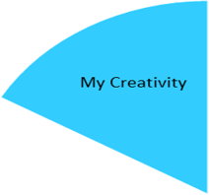
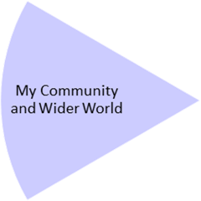
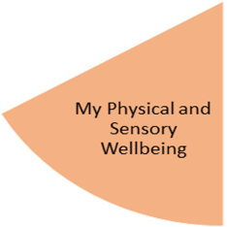
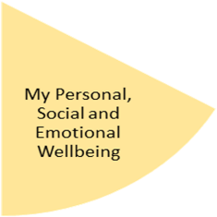
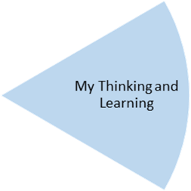
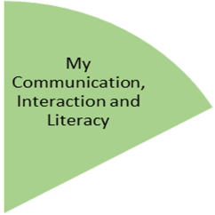
By the end of the topic— Pupils to have basic knowledge of positioning and direction. Understanding each method has a process specifically focusing and using the vocabulary terms of 1st, 2nd, 3rd etc.
Naming and understanding different types of plants. Including parts of a plant, colours and equipment needed to grow and maintain a plant.

By the end of the topic—
Pupils to show a basic understanding of their community surroundings and who/what jobs help us on a daily basis. Specific focus on developing their awareness of people who help us in school.
Food technology – Food from around the world

By the end of the topic— Pupil’s will have created structures related to different countries from around the world. Show an understanding of using and crafting different objects when trying to make a landmark.

Pupil’s will have attended music lessons and Open Theatre, delivered by an outside agency.

By the end of the topic— Pupils to show understanding of their community, how there are different communities all around us (schools, clubs, shops, classes) and develop an understanding of which community they are apart of.
Pupil’s will have experienced learning outside the classroom through forest school sessions and visiting the local community shops.

My Independence
My Health and Wellbeing
Preparing for My Future
By the end of the topic - In P.E. over the term, students will be attending weekly swimming sessions to develop their awareness when in and around the water.

By the end of the topic— Pupils will have developed an understanding of naming and identifying different countries from around the world linked with our termly book. Students will identify different communities /countries by describing and using pictures, words and sentences to enhance their analysing skills throughout the story book.

My Physical and Sensory Wellbeing lessons, pupils will have the opportunity to discover and learn to self-regulate their sensory needs. Pupils will participate in a range of lessons such as PE, cooking and movement breaks to develop an awareness of their body, senses and further developing fine and gross motor skills under the thematic approach.

My Community and Wider World
lessons, pupils will have the opportunity to explore the world around them through forest school and trips to places outside of school to build up engagement under the thematic approach.

My Creativity lessons are based around child-led activities giving pupils the ability to explore their creativity and develop engagement through art, music, and open theatre under the thematic approach.

