
Class: Norton
Summer Term Overview

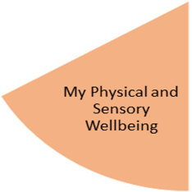
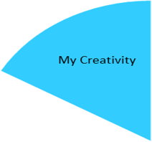

In Norton class, the students will be having movement brakes like going to gross motor room after finishing activities. Before any lesson, the students will be encouraged to join dancing activity which help them to release the energy and sit longer to finish their task.
The students will enjoy Uffculme daily mile every day in the morning 9:15 to 9:30 am.
The students will have PE lesson on Monday which will be planned and delivered by Mr. Johns.
The students will practice physical activities like walking and climbing when they go to Highbury Park.
AS Norton class is sensory and arty class, so most of the activities will be based on art and creativity. That will include all the lessons.
In out Art lesson the students will be experienced different textures like fabrics, yarns, pompoms, etc. They will decorate fabric bags, making birds and fairy dolls to decorate the classroom’s mini garden.
Cooking lesson: the students will learn different skills like rolling, stirring, chopping, blending, and pouring. They will be learning about kitchen’s equipment needed for cooking like spoon, chopping board, etc.
High function students will be learning about kitchen safety by taking them to food technology room and teaching them about using the oven, microwave, and hob.

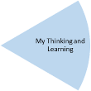
In our maths lesson, the students will be learning about positioning and direction. We have three lessons per week which will be covering one topic by different activities.
Week one, the students will be learning about inside and outside, they will be enjoying games, like throwing bean bags into a hoop, placing items with varied materials in and outside a box, and jumping in and outside a hoop.
Week two, the students will be learning about on and under. They will enjoy practical lessons like sitting on or under a chair, looking for items on the tables or under the tables and place them in ladled baskets.
Week three, the students will be learning about positioning (front, behind and between). They will be enjoying online games, communication boards and different objects to be paced according to the staff’s instructions.
Week four, the students will be learning about left and right. They will enjoy handprint to be matched and then to write the letter L on the left hand. The students will be encouraged to be engaged with an activity about learn how to remember left and right with a trick!
Week five, the students will be learning about counting forwards and backwards. They will enjoy online games, laminated worksheet, and other materials like blocks.
Week 6: the students will be learning about patterns. They will be creating or copying different patterns using different materials like cubs, lollipop sticks, twigs, sticks and laminated worksheets.
In our science lesson, the students will be learning about planting and looking after plants and parts of plants. We have six lessons; they will be learning about things we need for plants in a funny way by walking around the classroom and find the items that they have in their communication boards. They will be learning about parts of plant using real plants. Then they will create a small garden that will be sticked by the house they will make in other lesson. They will plant seeds, bulbs and vegetables like potato and onion and measure the length of the plants using cubs.
By the end of the term, the students will be able recognise how plants grow and what do they need to look after them.

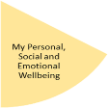
In Norton class, students are encouraged and supported to make themselves a breakfast every day. They will carry own same activity this term and they will be supervised by the staff to clean their plates when they finish eating snack, breakfast or when we have parties. The staff encourage them to look after their belonging and being responsible for their schoolbook, PE kits, lunch box and coats.
Last fifteen minutes of the last lesson, the students will be encouraged to clean the and tidy up the classroom that include vacuuming, wiping the tables, putting books and toys a way and washing up. By the end of term, they will go to the laundry room to wash spear clothes, aprons, and beddings. The staff will encourage them to wash their hands, brush their teeth and hair and to be ready to go home tidy and clean.
They will be encouraged to find their snack box and make a juice if they want.
By the end of the term, the students’ fine motors and gross motors will be stronger, they will gain more vocabularies and have better awareness of surroundings which will help with their independency.
In the PHSE lessons which are six lessons, the students will be learning about belonging (my family, my house) they will enjoy art lesson creating their house and sticking the pictures of people they live with. They will be learning about things they enjoy doing at home using communication boards and the doll house.
Third week, the students will be learning about people who help us in the school like SLT. A laminated work sheet with the picture of the staff will be used. The students will be learning about people who help us in the community like firefighter, constructors, and police. Al the lessons will be practical and sensory. Toys, different objects with different textured will be placed in a tuff tray so the students will have fun while they learn and extend their vocabularies.

Leisure lessons will be implemented in our timetable. The students will increase their vocabularies by enjoying bingo game. Each week will have bingo game that emphasise the topic of that week e.g., furniture, people who help us in the community, and planting. The students will enjoy online games too. The students will enjoy messy play once a week where they can enjoy sand play, water play, slime, Legos, etc.
Students will be learning about personal care and hygiene every day. However, personal care lesson once a week will emphasise learning about brushing teeth properly, brushing hair, and washing hands using the right tools and equipment.

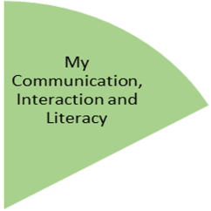
In our English lesson, the students will be learning and exploring the world around them. We have three lessons each week.
First week, Students will enjoy exploring part of a doll house increasing their vocabularies, e.g., kitchen, living room, bathroom, etc. they will be learning about the house furniture setting up furniture in the doll house. Higher function students to trace or write words of different furniture.
Second week, students will be learning about the function of furniture and devices we use in our house, (action words).
Third week, the students will be learning about wider circle, (our school). They will be learning about classes, things we need in our class. The students to be engaged walk in pairs with a staff member and explore the school, the staff to use communication board and walk around the school to find the rooms like PE hall, sensory room, etc.
Fourth week, the students will be learning about (our community, the parks around me). The students to explore different material and textures, they use twigs, leaves, rocks, and other different materials to create a park including playing aeras, ponds, and learning about things we can do in a park. The students collect things when they go to Highbury Park to help creating a park.
Fifth week, students will be learning about supermarkets, they will be creating a supermarket including shelves with different items like vegetables, cleaning things, food, etc. the students will be supported to have outside learning trip to Asda and have experience of buying and learn how to pay using visa card and cash. Students with higher abilities to make a shopping list.
Sixth week, some of the students in Norton class are very scared from doctors and hospitals. In our literacy lesson they will be learning in a funny way about doctors and nurses as part of the community. They will be learning kits, equipment and tools used in the hospital, using tuff tray, and pretending game.
By the end of term, the students to be confidents using the communication board green board as they will use it in our arty sensory lessons.

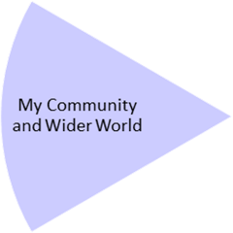
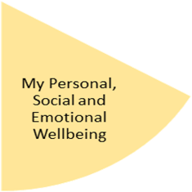
My Physical and Sensory Wellbeing lessons, pupils will have the opportunity to discover and learn to self-regulate their sensory needs. Pupils will participate in a range of lessons such as PE, cooking and movement breaks to develop an awareness of their body, senses and further developing fine and gross motor skills under the thematic approach.

My Community and Wider World
lessons, pupils will have the opportunity to explore the world around them through forest school and trips to places outside of school to build up engagement under the thematic approach.

My Creativity lessons are based around child-led activities giving pupils the ability to explore their creativity and develop engagement through art, music, and open theatre under the thematic approach.

