
Class: Osborne
Summer Term Overview
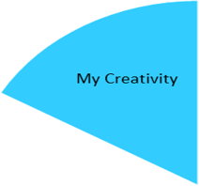
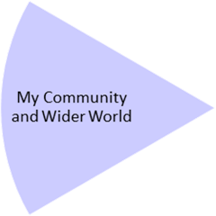
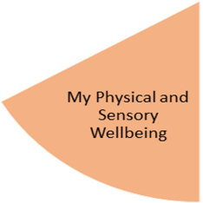
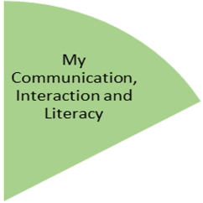
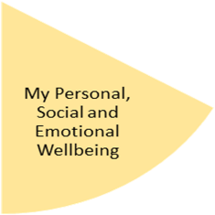
Students will listen to songs and stories, to retain the language including object names in different environments. We will be learning about world around us through different perspectives and locations in our environment. This will be done as functionally and practically as possible by giving students different opportunities like exploring a doll house, our local parks and shops, the people who help us school and the community and sensory stories. In writing, students will have opportunities to develop their mark making and handwriting, as well as common action and object words.

In Art we will be focusing on craft and textiles. Pupils will be practice to learn the skill of weaving different materials to create a variety of products. Music and drama sessions will continue to be provided through our Open Theatre sessions and visiting music teacher

My Physical and Sensory Wellbeing lessons, pupils will have the opportunity to discover and learn to self-regulate their sensory needs. Pupils will participate in a range of lessons such as PE, cooking and movement breaks to develop an awareness of their body, senses and further developing fine and gross motor skills under the thematic approach.

My Community and Wider World
lessons, pupils will have the opportunity to explore the world around them through forest school and trips to places outside of school to build up engagement under the thematic approach.

My Creativity lessons are based around child-led activities giving pupils the ability to explore their creativity and develop engagement through art, music, and open theatre under the thematic approach.

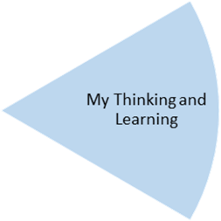
Pupils will be learning to understand about different aspects of belonging from recognising other people in different settings to grouping people according to a character or feature. They will continue to develop their independence in personal care and cooking by learning what is appropriate clothing and personal care according to the summer season.
Pupils will continue to explore the outdoor environment by attending forest school, local parks and trips local shops. This will support their understanding of different aspects of the world they will engage with around them.
For P.E they will be doing Gymnastics & Dance (travelling, rolling, balancing, tempo, rhythm, sequencing & expression) to support their physical and sensory wellbeing as well as yoga and relaxation sessions.
In Science we will have Plants and Horticulture focused lessons learning how to care, nurture and help grow our environment. Focusing on how to plant seeds, what we need to grow and identifying/ differentiating common plants and trees. In Maths we will be learning about preposition and direction which has cross curricular links with Science and learning about our natural environment. We aim to focus on simple direction by using them functionally in outdoor settings to progress towards using a simplified map.

