
Class: Cadbury
Summer Term Overview
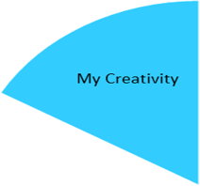
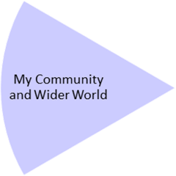
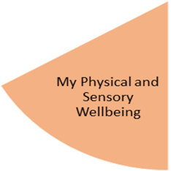
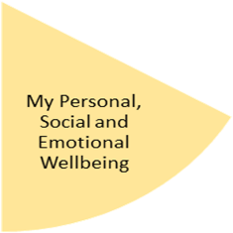
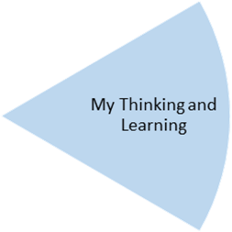
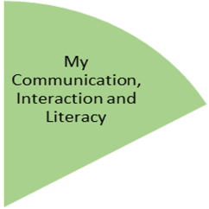
Under the theme of ‘Habitats’, in our English lessons students will focus on constructing sentences, using apostrophes and writing narratives.
We will also continue our ‘Jump Start’ English sessions twice a week where we perfect our phonic knowledge to help improve our reading skills.

My Physical and Sensory Wellbeing lessons, pupils will have the opportunity to discover and learn to self-regulate their sensory needs. Pupils will participate in a range of lessons such as PE, cooking and movement breaks to develop an awareness of their body, senses and further developing fine and gross motor skills under the thematic approach.

My Community and Wider World
lessons, pupils will have the opportunity to explore the world around them through forest school and trips to places outside of school to build up engagement under the thematic approach.

My Creativity lessons are based around child-led activities giving pupils the ability to explore their creativity and develop engagement through art, music, and open theatre under the thematic approach.

Careers: our Careers Advisor will continue to meet with our KS3 students. There will be opportunities to meet employers/employees.
RE: students examine the themes of Being open, honest and truthful; silent and attentive; courageous and confident; hopeful and visionary.
Outdoor Learning (John Muir): students will continue to focus on conservation work.
Geography: Students will explore Australia, focusing on climate, population and culture. We will be exploring the aboriginal people and the importance of Uluru to them, then look at coastal features and the threats the Great Barrier Reef is facing.

Within their PE lessons, students will be engaging in and learning about the different skills involved in Gymnastics & Dance - travelling, rolling, balancing, tempo, rhythm, sequencing & expression.
Students will also visit Shirley Golf Club every Wednesday.
Art: the focus for students will be Sculpture, structure, inventiveness and determination. Exploring how to make different structural pieces but they also just as importantly explore how it feels to make art. They explore how they can appreciate a sense of challenge, and a feeling of trying things out without fear of failure or “wrong or right”.
Music: our music sessions are delivered by Services for Education.

In PSHE, students explore real-life issues and how they can recognise and deal with them appropriately. This half-term students will focus on relationships, and the sensitive issues of domestic violence and radicalisation.
Throughout the half-term, students reflect on their progress towards achieving their personal targets linked to their EHCPs.
Food Technology : students will be following Food: A Fact of Life.—Healthy Eating programme. Students will learn about healthy eating and prepare a range of healthy meals and snacks whilst also learning the importance of health and staying active.
Science: Students will continue their study of electricity and magnetism learning about their effects and uses, and the links between the two.
Mathematics: students will practically explore types of measurement – including length and height but also measuring time as well.

