KS3 Main Overview of the Curriculum 2024 - 25
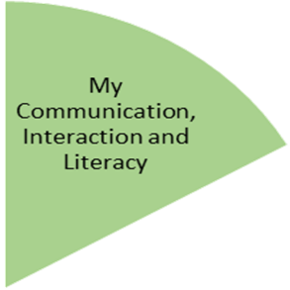

 | Autumn Term | Spring Term | Summer Term
English  R:\1 Secondary Files\PlanningSOWCurricMaps\KS3 Main Planning 24 - 25 | NC Year 1  Autumn 1: Food (using noun phrases, spelling contractions, predicting events, writing recipes)  Autumn 2: Traditional Tales (punctuation, contractions, understanding features of tales, write own tales)  NC Year 2  Autumn 1: Roald Dahl (conjunctions, adverbs and prepositions, irregular words, inference, punctuating speech)  Autumn 2: Robots (apostrophes and pronouns, prefixes and suffixes, research paragraphs)  NC Year 3  Autumn 1: Robin Hood (possessive pronouns, words with ch, gue and que, features of legends, write own legend)  Autumn 2: Science Fiction (apostrophe and adverbials, prefixes and suffixes, features of Sci-Fi, write own Sci-Fi) | NC Year 1  Spring 1: Zoo (connectives, suffixes, inferences, tenses)  Spring 2: Ourselves (questions, suffixes, fictions/ non-fiction, proof-reading/ correcting)  NC Year 2  Spring 1: Kings, Queens and castles (complex sentences, dictionaries, features of fiction, drafting and amending)  Spring 2: Aliens (determiners, homophones, performance poetry, extended sentences)  NC Year 3  Spring 1: Dragons (clauses and connectives, homophones, writing styles, diary entry)  Spring 2: Normans (time and cause, words with ce, ff, ss, ei, interpretation and comparing, range of structure in composition) | NC Year 1  Summer 1: Habitats (sentences, apostrophes, stories, writing narratives)  Summer 2: Pirates! (connectives, exception words, phonics, instructions)  NC Year 2  Summer 1: chocolate (improving writing, ending in -sure and -ture, using context, handwriting)  Summer 2: Superheroes! (revise grammar and punctuation, spelling patterns, text structure, character, set and plot)  NC Year 3  Summer 1: Jacqueline Wilson (tenses, suffix – ly, inference, settings, plot and narrative)  Summer 2: Rainforest (possessive pronouns, suffixes -ous, -ly, show not tell, ingredients of a good story)

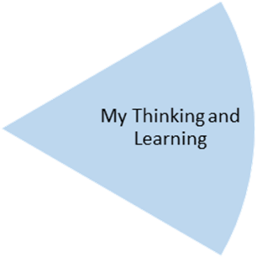

Mathematics  R:\1 Secondary Files\PlanningSOWCurricMaps\KS3 Main Planning 24 - 25\Maths - White Rose  https://whiteroseeducation.com/resources | Autumn Term | Spring Term | Summer Term
 | NC Year 1  Number - place value  Number - addition and subtraction  Shape – properties of 2-D shapes  NC Year 2  Number - place value  Number - addition and subtraction  Shape – properties of 2-D shapes  NC Year 3  Number - place value  Number - addition and subtraction  Number – multiplication and division | NC Year 1  Number - place value  Number - addition and subtraction  Measurement – length and height  Measurement – mass and volume  NC Year 2  Measurement - money  Number - multiplication and division  Measurement – length and height  Measurement – mass, capacity and temperature  NC Year 3  Number – multiplication and division  Measurement – length and perimeter  Number – fractions  Measurement – mass and capacity | NC Year 1  Number - multiplication and division  Number - fractions  Geometry – position and direction  Number - place value  Measurement – money  Measurement - time  NC Year 2  Number - fractions  Measurement – time  Statistics  Geometry – position and direction  NC Year 3  Number – fractions  Number - money  Measurement – time  Geometry – properties of shape  Statistics

Science  (Cycle 3 24-25)  R:\1 Secondary Files\PlanningSOWCurricMaps\Science | Autumn Term | Spring Term | Summer Term
 | Autumn 1: Biology  Genetics and Inheritance  Autumn 2: Chemistry  Particles  Elements, Atoms and Compounds | Spring 1: Physics  Sound  Light  Spring 2: Biology  Health and Lifestyle | Summer 1: Chemistry  Acids and Alkali  Periodic table  Summer 2: Physics  Energy and Heat

Computing  (Twinkl – PlanIt)  R:\1 Secondary Files\PlanningSOWCurricMaps\KS3 Main Planning 24 - 25\Computing  https://www.twinkl.co.uk/resource/tp2-i-252-computing-subject-overview | Autumn Term | Spring Term | Summer Term
 | NC Year 1  Online Safety/ Computer Skills  NC Year 2  Online Safety/ Technology Around Us  NC Year 3  Online Safety/Online Searchers and Surfers | NC Year 1  Word Processing Skills  NC Year 2  Using the Internet  NC Year 3  Word Processing | NC Year 1  Painting  NC Year 2  Computer Art/ Presentation Skills  NC Year 3  Drawing and Desktop Publishing  Presentation Skills

Food Tech  (Food - a Fact of Life)  Cycle 2 24-25  https://www.foodafactoflife.org.uk/ | Autumn Term | Spring Term | Summer Term
 | Seasonal Food | Healthy Eating | Global Food including food etiquette and culture

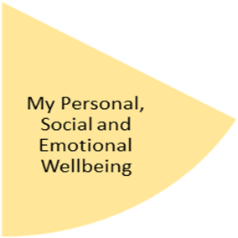  PSHE  (Cycle 2 24-25)  Z:\1 Secondary Files\PlanningSOWCurricMaps\PSHECC\PSHE 24-25 or  Z:\1 Secondary Files\PlanningSOWCurricMaps\KS3 Main Planning 24 - 25\PSHE | Autumn Term | Spring Term | Summer Term
 | Specific  SA3 prejudice and discrimination (inc Hate Crime)  General  SA1 personal strengths  SA2 skills for learning  SA4 Managing pressure  SSS4 keeping safe online  SSS5 Emergency situations | Specific  CG3 Healthy and unhealthy relationships  CG5 long-term relationships/ parenthood  General  CG2 Friendship  MF1 self-esteem and unkind comments  MF2 Strong feelings | Summer 1  HL3 physical activity  HL4 healthy eating  HL5 body image  Summer 2  TWILI2 Managing online information  TWILI3 Taking care of the environment

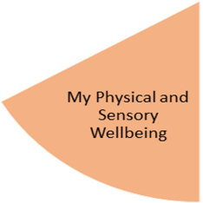  P.E.  Cycle 2 (24-25) | Autumn Term | Spring Term | Summer Term
 | Autumn 1  Cricket/ Throwing, jumping and running  Autumn 2  Tackling, shooting, passing and dribbling | Spring 1  Tumbling  Spring 2  Tennis/ Olympic games | Summer 1  Cricket/ Map and reading skills  Summer 2  Attacking games

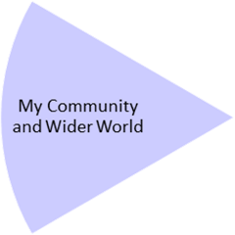  History/ Geography  (Year 2 Our National)  Z:\1 Secondary Files\PlanningSOWCurricMaps\KS3 Main Planning 24 - 25 | Autumn Term | Spring Term | Summer Term
 | Autumn 1  Geography – The UK (Lessons 1-7 migration, multiculturism, EU)  Autumn 2  Stone Age to Iron Age | Spring 1  Geography – The UK (Lessons 8-15 climate and water cycle)  Spring 2  Anglo-Saxons | Summer 1  Geography – Chinn Brook Project (Lesson 16-22)  Summer 2  Fire of London

Religious Education  (Year 1)  Z:\1 Secondary Files\PlanningSOWCurricMaps\KS3 Main Planning 24 - 25\RE | Autumn Term | Spring Term | Summer Term
 | Autumn 1  Who wants to be a Millionaire?  Autumn 2  What does it mean to be a Jew? | Spring 1  How did it all start?  Spring 2  How do I decide? | Summer 1  What does it mean to be a Buddhist?  Summer 2  Being Human

Outdoor Learning  John Muir | Autumn Term | Spring Term | Summer Term
Outdoor Learning  John Muir | Autumn 1  Autumn 2 | Spring 1  Spring 2 | Summer 1  Summer 2

Careers | Autumn Term | Spring Term | Summer Term
Careers | Personal strengths (withing PSHE curriculum)  Skills for learning (withing PSHE curriculum) | TBC | Cycle 1 23-24  TWILI1 Diversity, rights and responsibilities (withing PSHE curriculum)  Cycle 2 24-25  TWILI2 Managing online information (withing PSHE curriculum)  Cycle 3 25-26  TWILI4 Preparing for adulthood (withing PSHE curriculum)  TWILI5 Managing finances (withing PSHE curriculum)

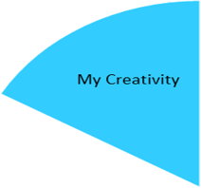  Art  Access to Art (Year 2)  Cycle 1 (24-25)  Z:\1 Secondary Files\PlanningSOWCurricMaps\ART PLANNING\Key stage 3 Main  https://www.accessart.org.uk/primary-art-curriculum/ | Autumn Term | Spring Term | Summer Term
 | Autumn 1  Explore and draw  Autumn 2  Exploring the world through print | Spring 1  Be an architect  Spring 2  Expressive painting | Summer 1  Stick transformation project  Summer 2  Music and art

Music  Cycle 2 (24-25) | Autumn Term | Spring Term | Summer Term
Music  Cycle 2 (24-25) | Autumn 1  Unit 1: Writing Music Down  Autumn 2  Unit 2: Playing in a Band | Spring 1  Unit 3: Compose using your Imagination  Spring 2  Unit 4: More Musical Styles | Summer 1  Unit 5: Enjoying Improvisation  Summer 2  Unit 6: Reflect, Rewind, Replay 2

