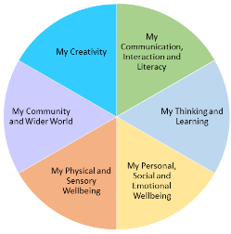 | Timetable  Hedgehogs  Autumn 1 2022

 | 9-10 |  | 10-10:45 |  | 10:45-11 | 11-11:30 | 11:30- |  |  | 12 | -12:15 | 12:15-12:45 | 12:45-1:15 | 1:15-2:00 |  | 2:00 -2:15 | 2.15-2.45 | 2:45
Monday | Breakfast | Gymnastics |  |  |  |  |  |  |  | Medical needs | Storytime | Dinner | Play outside | Maths |  | Outside | Guided Reading | End of day prep
Tuesday | Walk  Breakfast |  | Computing |  | Play Outside | English | Storytime | Music 11.45 |  |  | Music -12.15 |  |  | Science |  |  | Phonics | End of day prep
Wednesday | Walk  Breakfast |  | Art |  |  | Shopping or Recipes |  |  |  |  | Storytime |  |  | Cooking room  Lindsay |  |  | Guided Reading | End of day prep
Thursday | Walk  Breakfast |  | Open  Theatre  -10.30 | Whiteboard activities |  | Maths |  |  | Storytime |  | Change for FS |  |  | Forest school |  | Change clothes | PE  2:15-2:45
Friday | Walk  Breakfast |  | English |  |  | Harvest | Maths games |  |  |  | Storytime |  |  | Hobbies | 1:45  Tuck Shop | Play | Phonics | End of day prep

